**Sentiment Analysis of Amazon Product Reviews - Project Documentation**

**1. Project Overview**

* **Objective:** Perform sentiment analysis on Amazon product reviews to gain insights into customer satisfaction.
* **Tools Used:** R (dplyr, tidytext, ggplot2, wordcloud)
* **Outcome:** Identify key sentiment patterns and high-frequency terms related to customer experience.

**2. Data Preparation**

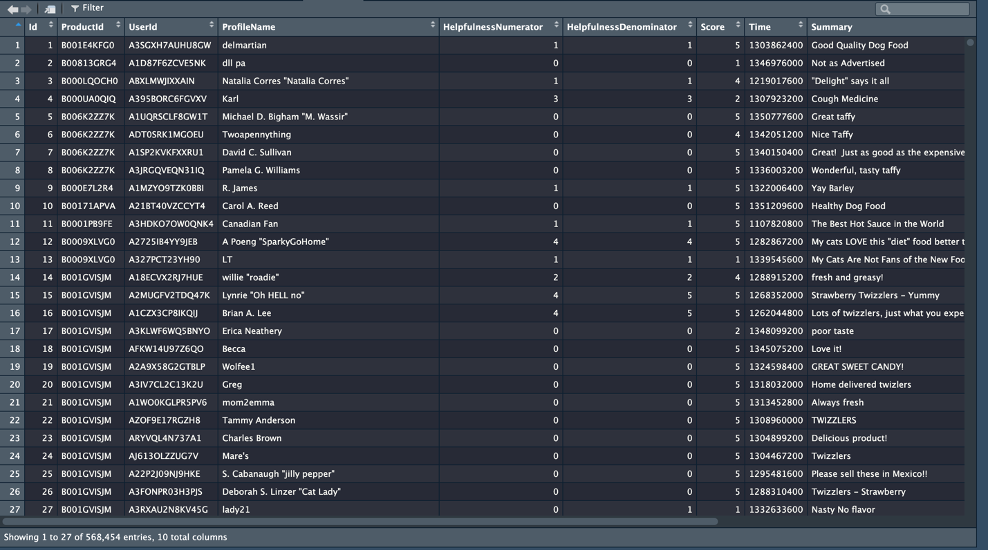

This dataset includes product review text processed by removing stop words and isolating keywords for analysis.

**3. Word Clouds for Positive and Negative Sentiment**

**Positive sentiment words**

**Negative sentiment words**

The word clouds showcase high-frequency words in reviews with positive and negative sentiments. Larger words represent higher frequencies, indicating key aspects of customer opinions.

**4. Mean Rating vs. Sentiment Score Scatter Plot**

Each point represents a product, with color-coded quadrants helping to differentiate sentiment categories. It enables identification of products with strong positive or negative sentiment.

**5. Summary Views of Product Ratings and Sentiments**

These views present a detailed breakdown of ratings and sentiment scores per product, providing a data-driven snapshot of customer sentiment trends across the product range.